Practical 5 – Configuration Management

Configuration management is a process used to establish and keep a product's performance, functionality, and physical characteristics throughout its life in accordance with its specifications, design, and operational data.

(From https://en.wikipedia.org/wiki/Configuration_management)

This practical provides an introductory exploration in using Git Desktop.

**Prerequisite**

Students are required to sign up a GitHub account at GitHub.com

Upload the provided files into the GitHub web.

**Integrate GitHub Desktop with web version**

1. Download GitHub Desktop edition from <https://desktop.github.com/>.
2. Launch GitHub Desktop edition. Sample screen of Github Desktop will be shown as following:

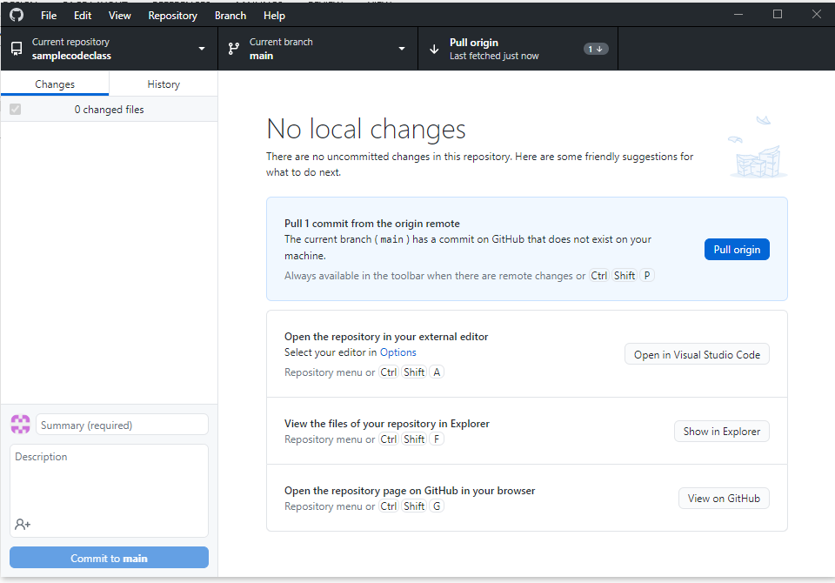

1. From the **File** menu, select **Clone** Repository. (or you may select **Clone Repository** from the sidebar at left side of screen, if available). The following message will be displayed.

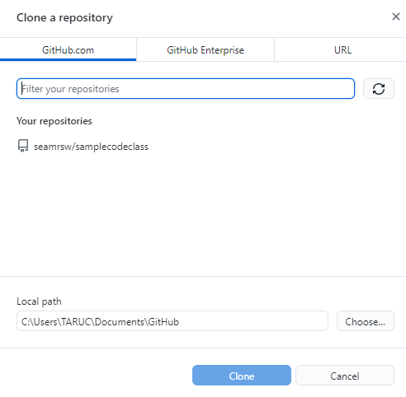

1. From **GitHub.com** tab. Type *seamrsw* in the textbox. Then click **clone.**
2. Form the screen, select **Show In Explorer** to view the content.

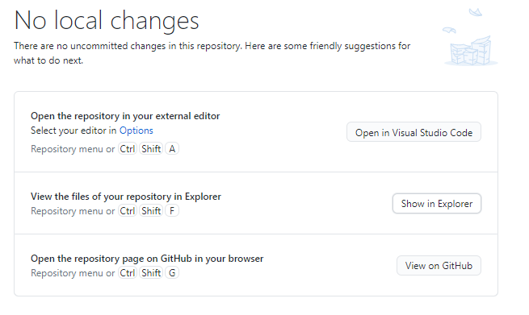

1. You will see the content of the repository in local windows explorer screen.

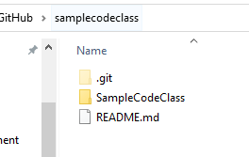

1. In the SampleCodeClass folder, double click and access to **src** folder for the **Student.java** file.
2. Open the file with Notepad, and make some minor changes in the file. For example, put a blank function code **void myTest()** (You may put other changes if the myTest() already exist). Close Notepad and switch to GitHub Desktop, You will notice change is recorded in GitHub Desktop.

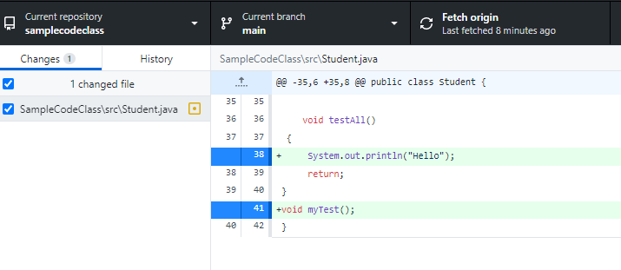

1. On the bottom of left side bar, press **commit to main (commit changes)** button. Then, press **push origin** button (button in the main screen).
2. From the **History** tab, you may see the history of file updates.
3. Log into GitHub website (github,com), username *seamrsw*, password, *github220238*. Check the Student.java in GitHub web version. Changes has committed into web version github.

**Creating and compare branch**

1. In the GitHub Desktop, create a new branch named B1. To do this, from the branch menu, click **New Branch**. Type in B1 for the branch name. (Brought all changes to the new branch if being asked). **Publish** the B1 branch to the remote website.
2. Now, we are dealing with the B1 as current branch. You may switch the current branch as main or B1 branch, just by clicking on the branch name at the **Current Branch** tab.
3. Make sure your current branch is B1 branch.
4. Add a new function into the codes, let say, int countAll() { return 0; }. You may use Notepad to open the Student.java file through explorer.
5. Commit to B1 after changes has made.
6. Now, you will have main branch and B1 branch. To shows the difference between branches, you may use the **compare to branch** function. Try to observe how to achieve and use this function.

**Student exercise**

1. Try to explore the revert commit on a branch.
2. Demonstrate how to merge branches.